**OrientBoard 各类组件需要的数据格式**

1. Title, 只需要直接创建，不需要接收数据；



1. 柱状图、饼图、线图数据格式一致，如下：

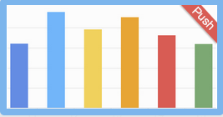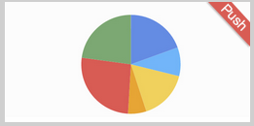

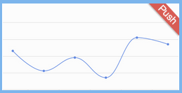

{"MsgID":"weigui","username":"wangbilin",

"payload":{"value":[["xxss",140000000],["xxx餐厅",10005120],["xxx 鞋厂",6200320],["test",1680000],["xxxxxxxx",143360]]}}

1. 计数、仪表盘数据格式一致，如下：

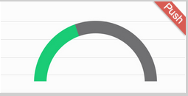

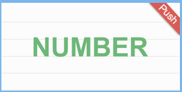

{"MsgID":"rsp_Day_Count","username":"wangbilin","payload":{"value":"106120"}}

1. 表单，数据格式如下所示，

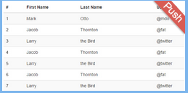

{"MsgID":"weiguireason","username":"wangbilin","payload":{"value":[["reason","count"],["商业贿赂",39270],["超出经营范围",23562],["法人有黑名单",23562],["滥用市场支配地位",7854],["不正当竞争",7854]]}}

注：使用table时注意value第一个元素表示table的属性名，格式为字符串。如图所示

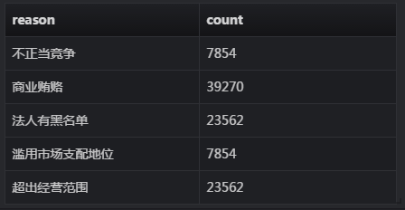

1. 时间线

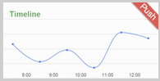

{"MsgID":"timeline2","username":"wangbilin","payload":{"ts":1430792272557,"value":5120}}

注：一次只需传一个值